Code Debug
Buggy code

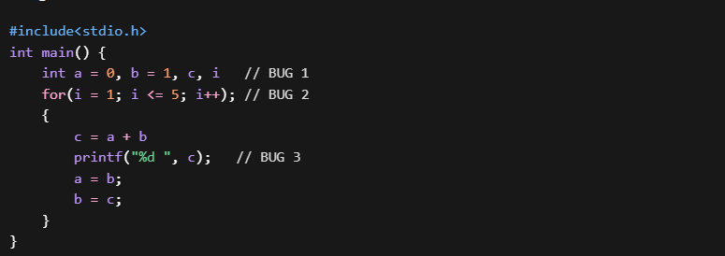
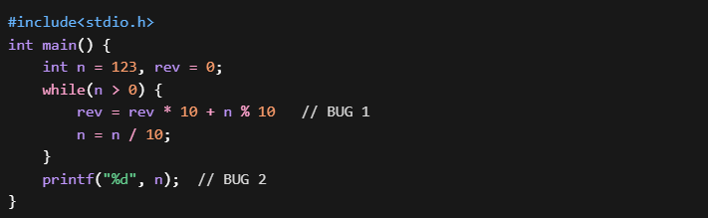
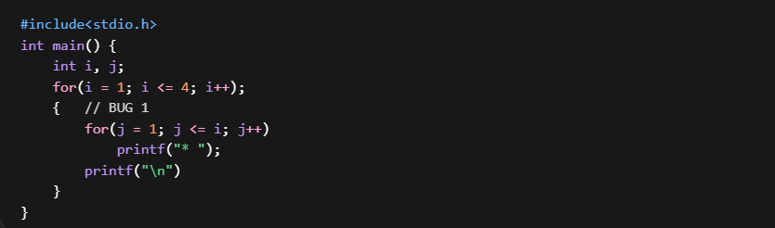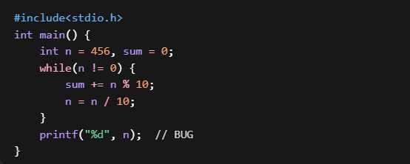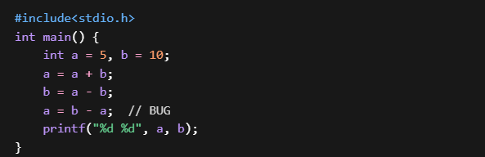
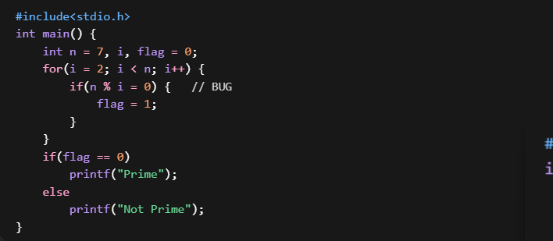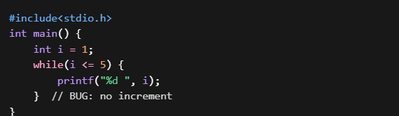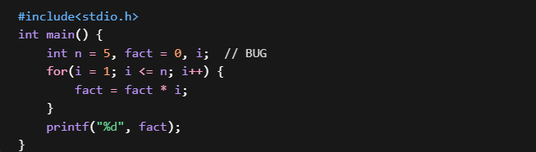
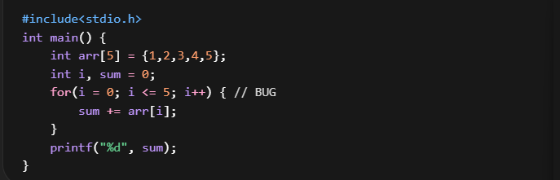
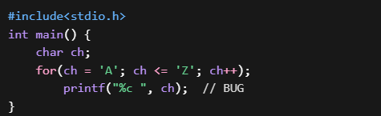
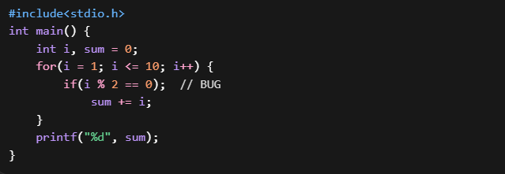
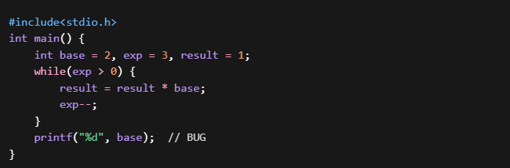
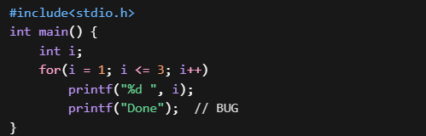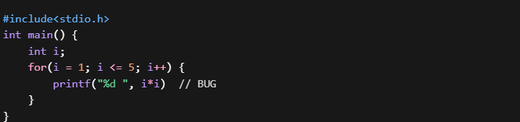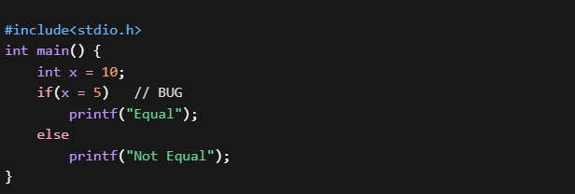

Correct output
1 2 3 5 8
321
*
* *
* * *
* * * *
15
10 5
Prime
1 2 3 4 5
120
15
A B C D E F G H I J K L M N O P Q R S T U V W X Y Z
30
8
1 2 3 Done
1 4 9 16 25
Not Equal

